**Final Year Project Report**

**ECE4094, Project B – Final Report**

**Image classifier: Speed-limit Signs**

_______________________________

Name: Haoyi Sar

Student ID: 26891611

_________________________________________________________

A report submitted in part fulfilment of the degree of

**BSc (Hons) in Electrical and computer systems Engineering**

**Supervisor:** Titus Tang



Department of Electrical Engineering

Monash University, Australia

**Significant Contributions Page**

* Created python scripts to reformat annotations from a dataset
* Created python scripts to organise dataset for use
* Created a python script to modify and transfer files
* Created python scripts to modify images to enhance performance
* Created python scripts that measure the specifications of the dataset
* Modified a script to detect multiple images.

**poster**



**Executive Summary**

Main topics:

* Utilise neural networks for object detection/ classification for geographic use

Approach to task:

* Use well-known CNN (Yolov3) as framework for speed-limit detection
* Modify the model to suit specific task

Key Aspects:

* Modify datasets to utilise find optimal use of the yolov3 model
* Optimise the hyperparameters of the neural network

Important findings:

* Found the key parameters the help optimise the network
* Found the weaknesses in the design why they occur and how they can be improved

Main outcomes:

* Learning on the architecture of the yolov3 model and coding in python
* Understanding the behaviour of neural networks and how they work

Conclusions:

* Created an object detector that detects and classifies different speed-limit signs.

Contents

**Final Year Project Report** 1

Name: Haoyi Sar 1

Student ID: 26891611 1

**Significant Contributions Page** 2

**poster** 3

**Executive Summary** 4

**Introduction** 6

**Background** 7

**Literature Review** 8

**Yolov3:** 8

**Training yolov3:** 11

**Overview** 16

**Detailed Discussion** 17

**Choosing the language: Python** 17

**Choosing the framework: TensorFlow** 17

**Computing power required:** 17

**The Dataset:** 18

**The Neural Network:** 19

**Test/ Experimental Results and Discussion** 22

**Installing Tensorflow-GPU (CUDA):** 22

**Preparing a suitable Dataset:** 23

**Familiarising with python & TensorFlow:** 24

**Experimenting and familiarising with the Yolov3 neural network:** 25

**Training my own yolov3 Neural network with a recommended dataset:** 26

**Using the street-sign Dataset:** 28

**Images of results:** 35

**Some larger images:** 39

**Conclusions & Future Work** 3

**Conclusions:** 3

**Future work:** 3

**References** 5

**Appendices** 7

**Definitions for convenience:** 7

**Introduction**

The topic of the project is machine learning, more specifically CNN’s (convolutional neural networks). CNN’s play a huge role in modern image recognition systems as they are incredibly efficient at detecting image features.

Machine learning is a rapidly expanding field that has a lot of prospects for the future as it allows machines to do increasingly more complicated tasks that would usually require human labour. The thought of being able to automate things using computers at such a high complexity is an inspiration invoking thought and the bulk of the reasoning for my choice in this project.

CNN’s are evolved forms of Multi-layers perceptron’s using convolutions to extract features within part an image that allow detection of more complex patterns, compared the multilayer perception uses the whole image and is unable to isolate features.

There are various types of CNN’s (such as AlexNet, ResNet and LeNet) but the focus of this project is to use the Yolov3 created by Joseph Redmon. The aim is to use this type of neural network to create a program that can automatically detect and classify road signs within google street view. Show the location of the speed-limits on the map. Additionally, also map out the time it may take to arrive at various locations. This project is purely digital, no mechanical/ electrical components are required. I will also be implementing a unique dataset that is more specific to the required task.

**Background**

This project will be design and build based. Currently most neural network object detection is designed to detect different objects, usually different shapes. There also exists a popular hand-written digit classifier using the MNIST dataset to categorise different digits.

Neural Networks is a rapidly expanding field that allows computers the capacity to learn in a similar manner to the way humans do, involving things such as identifying various objects. Mimicking the way neurons are connected in the brain.

There are many different types of neural networks out there that are used for a wide range of different applications. Some popular types of neural networks involve autoencoders which are used to efficiently encode data by down sampling sets of similar data. CNN (Convolutional neural network) uses convolutions of matrices to detect features usually for image recognition and are commonly used for segmentation of images into various components. Object detection, the ability to identify desired objects in images. Classification, being able to categorise different types of objects. RNN (Recurrent Neural Network) can use their internal sate to process temporal behaviours and process sequences, commonly used for speech synthesis, rhythm learning and other audio related processing.

Our neural network will be mainly an object detection neural network however, our distinguishing factor will be that it will be also performing classification on these detected objects to categorise the different speed-limits.

detecting the images that have similar shapes as street-signs are usually an obvious circle or square. However, the specialty here will be giving it the ability to distinguish the numerical value of the speed limits and placing signs that are not speed limits within another category.

Training such a neural network will also require a dataset specific to the task, in this case we will need an abundant number of street-sign images to work with along with the labels for the image class and bounding box, which must be sourced one way or another.

**Literature Review**

## **Yolov3:**

Yolo is short for you only look once, can detect multiple objects, predicted classes and identify the location of an object within an image. It’s famous for it’s processing speed, enabling real-time object detection as it only needs to pass the image through the network once. In short, it analyses the entire image in one go.

It’s based off the original Darknet, which originally has 53 **CNN** layers (Darknet-53). But 53 more layers were added giving a total of 106 layers to improve detection. This has made Yolov3 slower compared to the previous versions. [1]

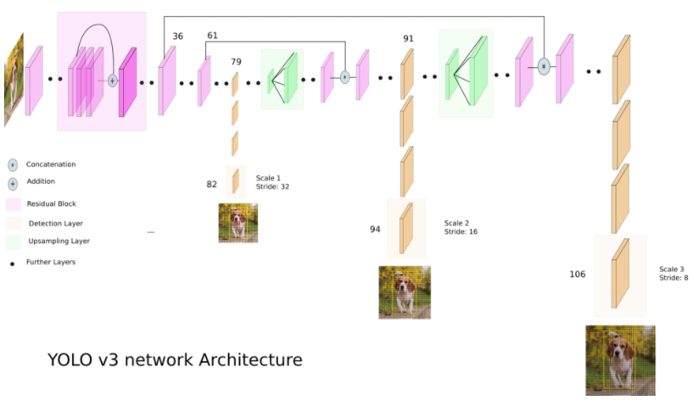

Figure Yolov3 Architecture by Ayoosh Kathuria [2]

On a 416x416 image Yolov3 operates by dividing the image into multiple cells using **strides** of 32,16,8 to divide the image into grid cells of 13x13, 26x26 and 52x52. This is done to allow the network to detect objects at 3 different levels of detail. Large (13x13), medium (26x26) or small (52,52).

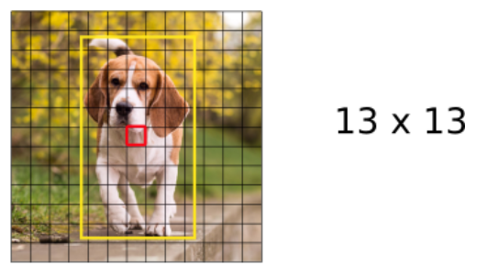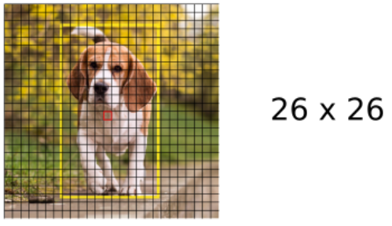

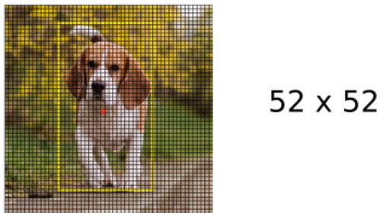

Figure The Image is analysed 3 times, at 3 levels of detail [3]

The input can receive image sizes of 416x 416 /608x608 /832x832 /1024x1024 as long as it is divisible by 32 as it must be compatible with the stride length. In this explanation we will assume the image size is 416x416. [1]

The first 81 layers **down samples** the image, the key layers are at 82 /94 / 106 where at the 1st detection layer, the images is divded into 13x13 grid cells and this occurs at layer 82. [3]

Assuming the usage of the COCO dataset with 80 classes, each cell will have (B*(5+C)) attributes.

* B is the number of bounding boxes, in yolov3 each cell will have 3 bounding boxes.
* 5 attributes for (centre-x, centre-y, predicted Width, predicted height, **objectness score**)
* C is the confidence for each class, with the coco dataset there will be 80 attributes in C.

Thus, in layer 82 the feature map will be (13,13,255). As there will be 255 attributes for each cell.

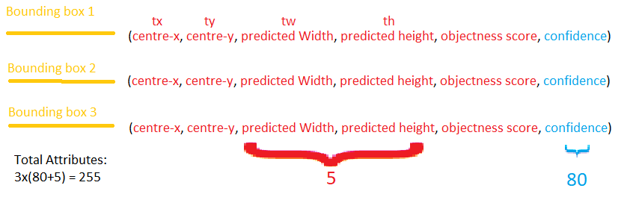

Figure Visualisation of the attributes

Each feature map is produced by 1x1 detection **kernels** at each of the 3 keys layers in the network 82 /94 / 106.

* Layer 82: (13,13,255)
* Layer 94: (26,26,255)
* Layer 106: (52,52,255)

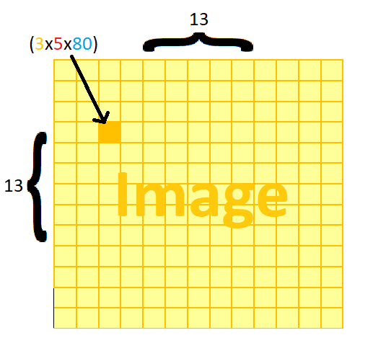

Figure Visualisation of the attributes of a cell in the 13x13 scale

At each scale, each cell predicts 3 bounding boxes using 3 **anchors**.

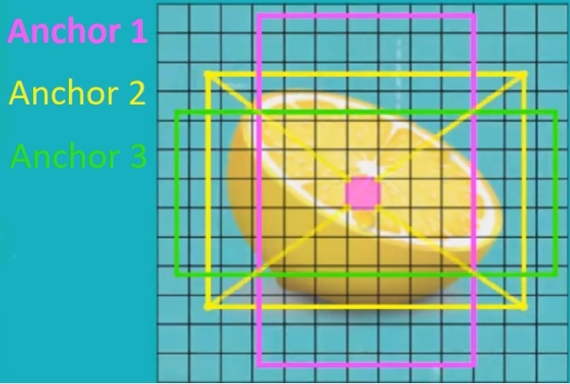

Figure The anchors contained within a cell [1]

### **Training yolov3:**

When yolov3 is training, it has a **ground truth bounding box** and we define which cells this the bounding box belongs to. When all the cells that the ground truth bounding box belongs to are identified, the centre cell is assigned by yolov3 to be responsible for predicting this object. And the objectness score for this cell is equal to 1, which is the highest value that can be assigned. This is one of the corresponding **feature map**’s cells that now is responsible for detecting the object. [1]

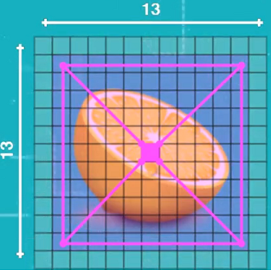

Figure The predicted bounding box detected by a cell [1]

But during training, all cells predict 3 bounding boxes each. So, in order to decide which bounding boxes are chosen for the object. We use anchors or priors. These anchors are used to calculate the predicted bounding box’s real width and height. The 3 anchor boxes for every grid cell are used for each scale of 13x13, 26x26, 52x52. That means each cell can predict 3 bounding boxes by using 3 anchors, to calculate these anchors **K-means clustering** is applied. Each anchor encodes 1 bounding box. [1]

The width and height of the anchor boxes for each scale are as follows.

|  |  |  |
| --- | --- | --- |
| Scale-1 (13x13):  (116x90)  (156x198)  (373x326) | Scale-2 (26x26):  (30x61)  (62x45)  (59x119) | Scale-3 (52x52):  (10x13)  (16x30)  (33x23) |

As we use the coco dataset we will have 80 confidences. The probability of each class being the true class is calculated by an element wise product of objectness score and list of confidences. Yolov3 then finds the element with the maximum probability and selects that as its predicted class. [1]

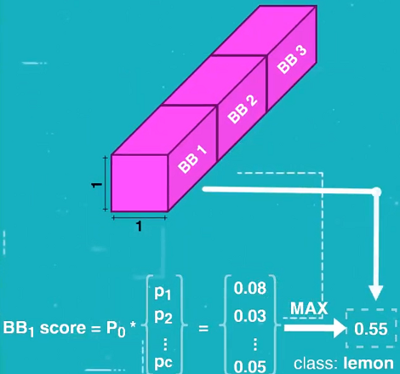

Figure Calculations for the Probability of a class [1]

This calculation is applied to all 13x13 cells across 3 predicted bounding boxes as well as across 80 classes.

* For Scale-1 (13x13): this results in 507 predicted bounding boxes.
* For Scale-1 (26x26): this results in 2028 predicted bounding boxes.
* For Scale-1 (52x52): this results in 8112 predicted bounding boxes.
* In total there are 10,647 that are filtered with **non-maximum suppression technique.** [1]

To calculate the width and height of the predicted bounding box. Yolov3 calculates offsets (eth, etw ) off the anchors. To predict centre coordinates of the bounding boxes, yolov3 passes output through **sigmoid function**, width & height and centre coordinates. [1]

The centre cell that is responsible for detecting the objects will have 3 anchors boxes, each of these anchor boxes will be used to calculate a predicted bounding box as the dimensions and coordinates of the predicted bounding box are offsets from the anchors. The predicted bounding boxes are calculated by using these equations. [1]

* tx, ty, tw, th are the output coordinates of the network after training.
* cx and cy are the top left corner coordinates of the cell.
* ph and pw are the anchor box’s width and height.
* bx,by, bw, bh are centre coordinates and width and height of the bounding box.

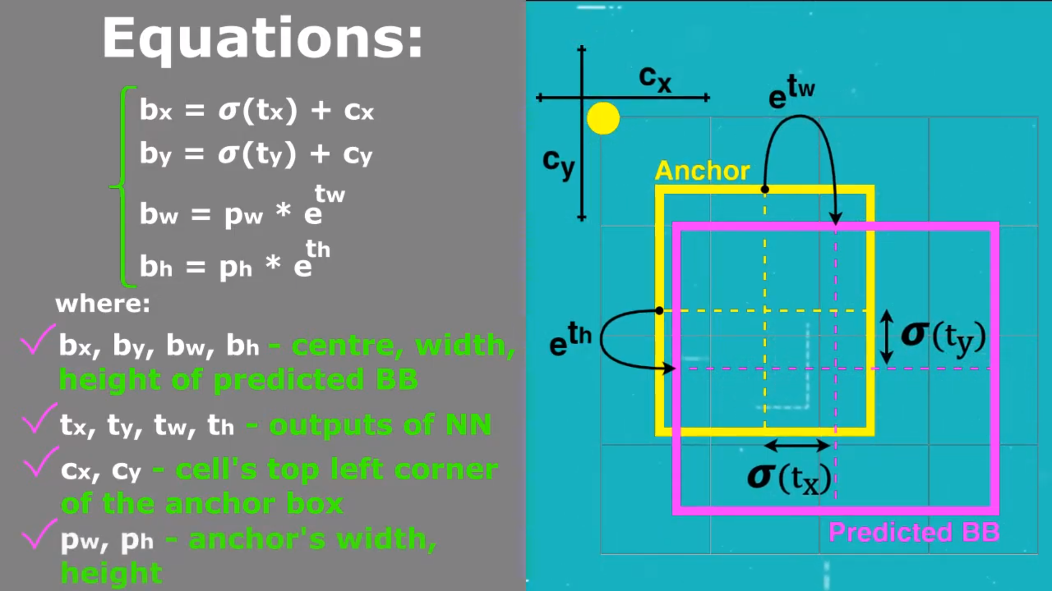

Figure Equations to calculate Bounding box from anchors [1]

**Weights** of the networks are updated while the network is training to make the predicted bounding box coordinates as accurate as possible. After training and after **forward pass**. The reason the bounding boxes are calculated in this fashion is to avoid unstable gradients. [1]

The centre cell that is responsible for determining a bounding box that captures an object will have an objectness score closest to 1. Consequently, surrounding cells will have objectness scores that are also close to 1, but not as high as the centre cell. The objectness values of the cells within the image will decrease as we move further away from the centre of the image. [1]

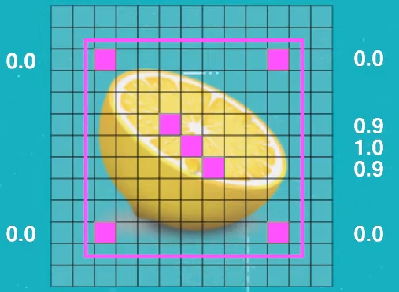

Figure Shows the distribution of the objectness score across an image [1]

The difference between objectness score and the class confidence is that the class confidence represents a particular class. Whereas objectness score contains probability that a cell is the centre of an object. Both these elements are necessary to enable both object detection and classification.

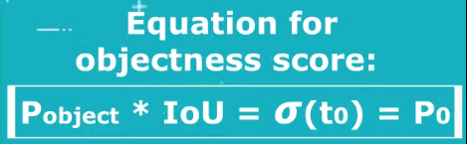

Figure Equation that calculates the objectness score [1]

**Overview**

* **Using python: for novelty and ease of use**
* **Using tensorflow as framework for the neural network**
* **Enabling the GPU to train the network for faster processing**
* **Using streetview dataset to train the model**
* **Choosing yolov3 as the model**

**Detailed Discussion**

## **Choosing the language: Python**

There are several useful languages for developing neural networks amount the most popular are python, c, Java.

While C may operate faster than python it does so at the sacrifice of usability by being much more difficult to debug and code. While great for producing high performance applications it is not beginner friendly.

My reason for choosing python is because it is currently the most popular language for building neural networks which means that it will be much easier to find resources regarding the topic to assist in my development of my neural network. While it is a new language for me, compared to the experience I have in C.

There are several IDE’s that work with python such as visual studio, PyCharm and IDLE. Visual studio is something we’ve learnt to use in uni, however I’ve decided to settle with PyCharm as it had a great interface and debugger system that I wanted to learn to use.

## **Choosing the framework: TensorFlow**

To choose the library there were some important differences to evaluate between the choices of PyTorch and TensorFlow. The advantages of using PyTorch involves being able to work with low-level API focused on direct and precise changes with the program to allow a high level of customisation which can be highly beneficial for more involved and specific development of programs. PyTorch also features a useful debugger that shows the step by step operation for the occurrence of an error.

TensorFlow on the other hand has higher performance speed which allows it to train larger networks faster, networks that would take days to train would take a much less time which may be good for larger scale operations and production in a business setting.

## **Computing power required:**

As we will be training the neural network from our home computer, it’d be beneficial for us to maximise it’s performance by enabling to GPU during training with CUDA. Running tensorflow with CUDA enabled will drastically increase the speed of the neural network as it enables Tensorflow to access the GPU. Neural networks also need an incredible amount of working space, and thus in order the train a network, a powerful RAM of 16Gb or more is recommended. I decided to settle for 24Gb, as this was a sweet spot for my budget.

## **The Dataset:**

Generally speaking, the greater the dataset size, the better the performance of the neural network.

However, within the dataset there are additional contributing factors that affect the performance.

1. Quality of the images

The images used by the neural network are resized to a 416x416 size therefore very small objects in high resolution images are difficult to detect

1. Variation within the images

The angle the image is shot at can make the object look different

1. Number of image classes

For every class of image being detect eg. (dog/ cats/ tables) needs data, therefore the more classes there are, the more images are required to gain a sufficient sample size for each class.

the larger the dataset size, the longer training will take. Some other points to consider are the size of the images as well as the quality and the level of variation there is within the images as well as how many classes there are. The more classes there are, the more images will be required to optimise the neural network.

One of the complications with this kind of project is that different countries will have different standards for their speed limit signs so I’m hoping that my neural network is able to adapt to this, however if the variation overwhelms the network I can focus on a specific country first.

For this neural network I have opted to obtain a dataset size of 52,000 different images of street-signs. Which should be enough data to train our neural network.

We will also need to make the right modifications to our label data, so that it is compatible with our neural network. Involving ensuring that the bounding boxes are in the correct place and also ensuring that format for the bounding boxes are exactly as required by the network.

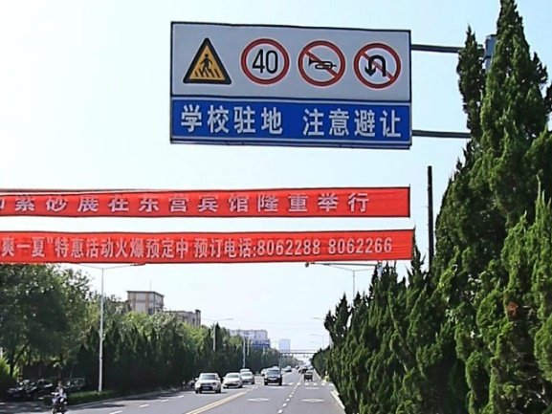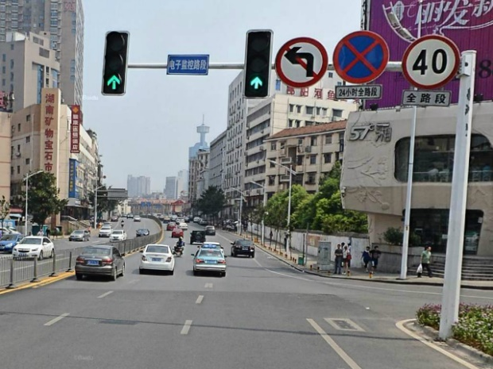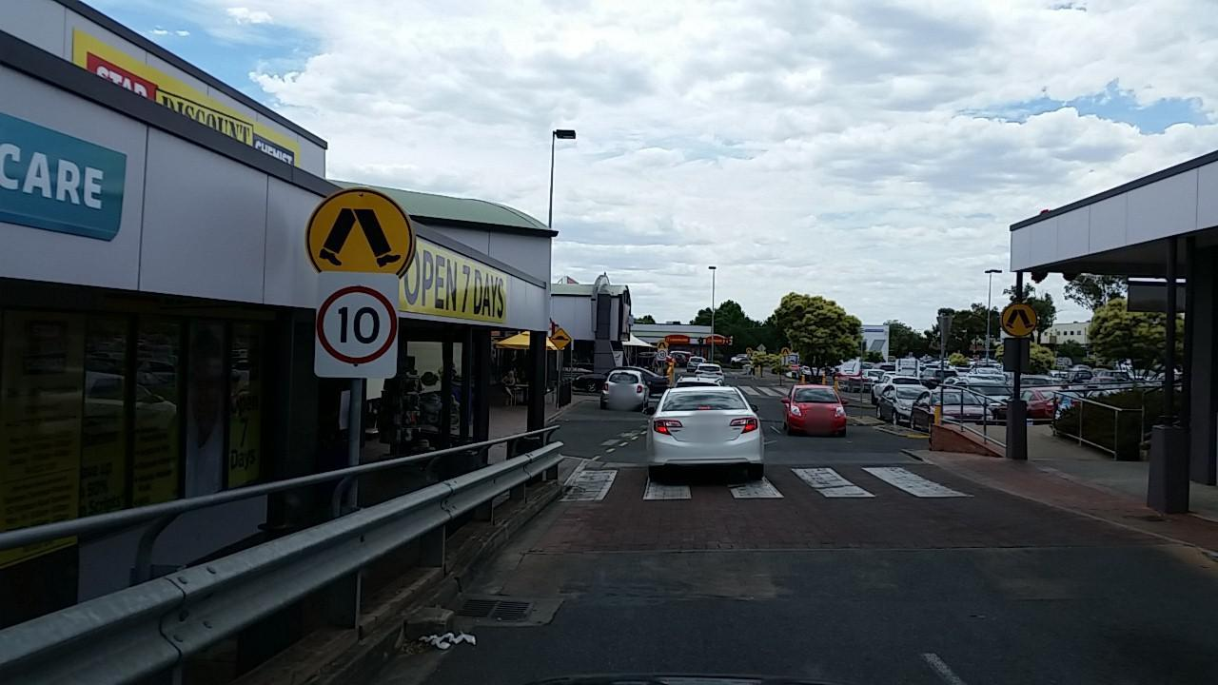

## **The Neural Network:**

There are many choices of neural networks, some better than others but more often than not, the choice will depend on the required task. To make this decision some key factors to look at for the performance will include things like the image size where we might have to customise our neural network to detect small/ large objects that may be hidden in a tiny portion of the image. The size of our database may dictate how quickly we need our neural network to train as ideally we would like the optimal accuracy possible before we run through the entire database, with smaller databases we may require a neural network that sacrifices other aspects for a faster learning rate. While conversely, if we have a larger database it is more beneficial to choose a network that can depict a higher level of detail at the cost of some other aspect, usually time.

In this project, as we are seeking to classify speed-signs. If in the occurrence of a real-world environment where a driver misinterprets a speed-limit would lead to disaster. We will require a higher level of accuracy to avoid these misinterpretations and consequently, avoid accidents. As the road is a fast pace, environment we also do not have the luxury of time to classify the speed-limits so, we would also want our classifier to interpret the signs at a reasonable speed.

Due to these factors, I have chosen the Yolov3(You Only Look Once) network created by Joseph Redmon, which offers the best of both worlds, it’s fast enough to be able to classify objects in motion such as cars driving or animals & people walking as demonstrated in several online videos. As well as consistently classify these people/animals and objects at a high level of accuracy.

The default data set that the Yolov3 network is trained on is the COCO dataset(Common Objects in Context). This dataset features thousands on different every day objects such as people, cats, dogs vehicles and so on. It also detects traffic lights and street-signs. While it is able to detect street signs on a general basis, it is however, unable to classify the street sign-type and the numbers and symbols on the sign. As it is unable to detect the speed on the sign, we will be modifying the dataset and specialising it towards being able to categorise speed limits.

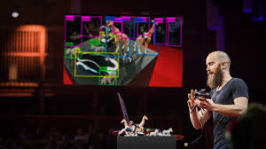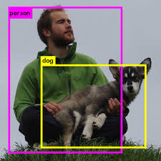

Figure Yolov3 Demonstration by Joseph R. Figure Yolov3 Demonstration by Joseph R.

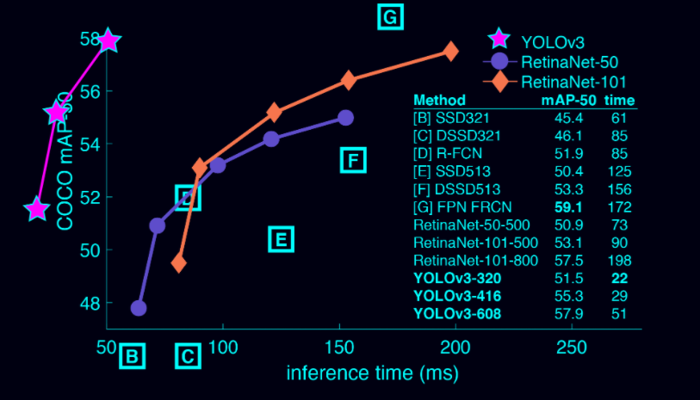

Figure Perfomance of Yolov3 compared to other Neural Networks

**Test/ Experimental Results and Discussion**

## **Installing Tensorflow-GPU (CUDA):**

One of the most surprising challenges was the installation of TensorFlow itself. The issue with TensorFlow is that in order for it to operate it was incredibly version dependant. Python needed to be a specific version, the modules such as OpenCV, matplotlib had different methods of installation either using conda or pip. These modules as I’ve also learnt were also only specific to a single virtual environment and sometimes would not operate on the IDE I was using (PYCHARM). So one of the nuances that I had to get used to was opening up the project interpreter to use the specific virtual environment that had all the modules I needed to utilise TensorFlow. Enabling CUDA on top of installing TensorFlow added an extra layer of difficulty, because certain instructions on the internet was only for specific versions of TensorFlow as well as not being configured to work for the IDE that I wanted to use.

I had to try several different combinations of installation and if one of them failed I’d uninstall the python package as I did not understand virtual environments at the time and it was difficult to track the directory of the installations when it was all done from the command prompt with no indication of the installation directory.

Combinations of installation I’ve tried.

Conda install (numpy, matplotlib, OpenCV, pandas)

Pip install (numpy, matplotlib, OpenCV, pandas)

Pip3 install (numpy, matplotlib, OpenCV, pandas)

I had the amazing idea of creating a system restore point in case any additional installation ruined the setup, however it was discovered the system restore does not back up these module installations. So when I ran into an error, I had to start the installation of Miniconda, TensorFlow and all the modules from scratch.

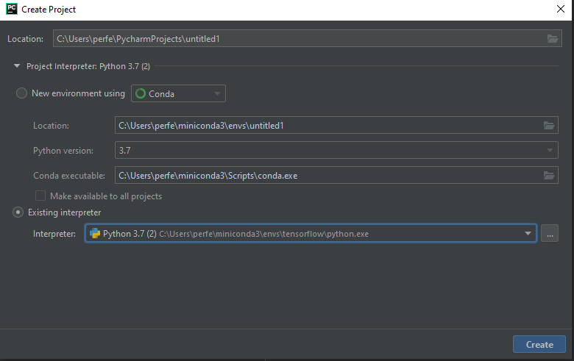

Figure configuring settings to the virtual environment

## **Preparing a suitable Dataset:**

When it came to datasets there were plenty of resources from sites just from browsing Google and YouTube, list of resources can be found in the appendix. Some of the things to consider were the styles of the dataset images, what country the speed-limit signs came from, how many there were and if they had labels on them or if I needed to label them on my own. Open Images Dataset V6+ [4] was a great resource for obtaining datasets for all different types of objects, however while it had street-signs within its database, it did not have categories for speed-limit signs and most the signs were not speed-limits. These factors negated this resource as an option.

I’ve tried to extract a dataset from google image search by writing a python script [5] made by Oh Yicong that allowed me to automatically download hundreds of images from google search. However just taking a look at a small sample size, a large proportion of the images were not in street-view format. Additionally, the searches also lost relevance after the first 200 images showing images that are less related to speed-signs the more images we search, therefore using these images for either training or testing was difficult.

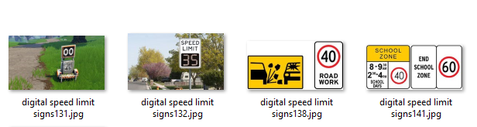

Figure Google Image download Sample

After browsing through several websites that offer street-view datasets, the one that caught my eye the most was from a company called Mapillary [6] and they offered me the permission to download 60,000 different street-view images that were already annotated in json format.

## **Familiarising with python & TensorFlow:**

Being completely new to python and TensorFlow, I required a few different resources to familiarise and learn the language and the TensorFlow framework. Some useful tools to help me build a foundation were sites such as Stack Overflow  where all the most commonly asked coding questions are answered by the community. I further installed a google extension called Grepper that displays code directly under your google search as a Grepper answer shown in figure.

Several other useful sources involved learning from youtubers such as Sentdex [7] , Socratica [8] & codecamp [9].



Figure Grepper Demonstration



Figure Sentdex

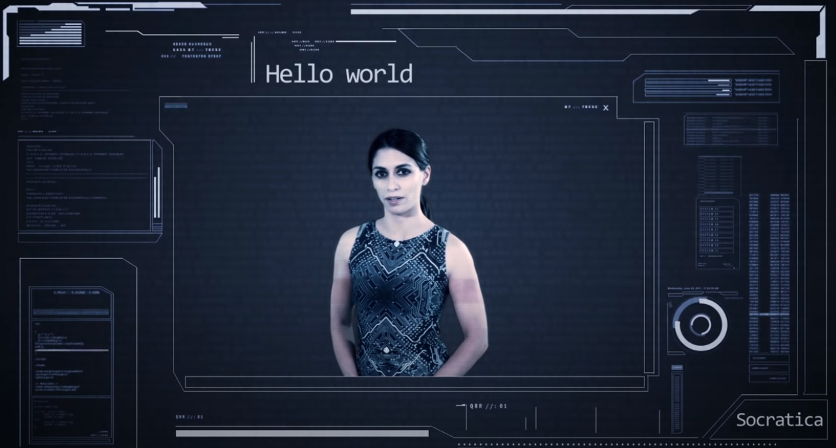

Figure Socratica Figure freeCodeCamp.org

## **Experimenting and familiarising with the Yolov3 neural network:**

To familiarise with the usage of yolov3 and to witness it’s functionality, I followed a video tutorial made by Pysource [10] that gave you a step by step process of writing a yolov3 deep learning algorithm using OpenCV. This was a relatively short process as following the code was simple and I had already installed OpenCV. After testing the model on several different images, the results were as incredible as the networked hyped it to be, being able to detect, several different objects with a high degree of accuracy at its precise location with the right labelling.

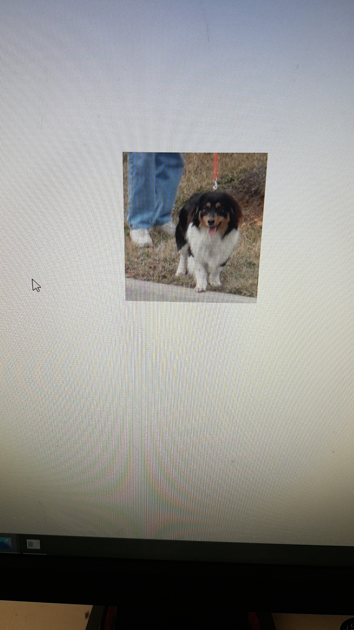

Figure Demonstrating classification and object detection

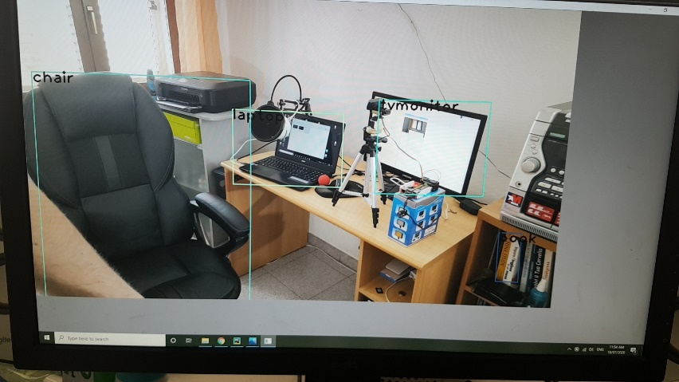

Figure Demonstrating classification and object detection

## **Training my own yolov3 Neural network with a recommended dataset:**

Using images from Open Images Dataset V6+ [4] of 7 different classes (bus, car, person, traffic light, traffic sign, Vehicle registration plate) with 400 images in each class. These images were downloaded using OiD_toolkitv4 [11] which is a github repository that allows you to automatically download any desired amount of images from Open Images Dataset V6+ with any desired classes available from the website through the windows PowerShell. Since the downloaded images are already have the bounding boxes and classes annotated.

The annotations however, are not in yolov3 format and need to be converted from XML to Yolov3 with another python script.

Once the image files and annotations were organised appropriately, I could start training the Yolov3 network. Some adjustments required to train the network on my personal computer required reducing the batch sizes to 4 and the number of epoch’s to 50.

With just 400 images in each class, as shown below it was able to detect the assigned classes fairly comfortably.

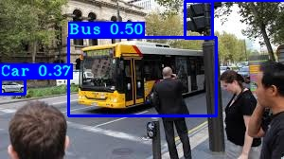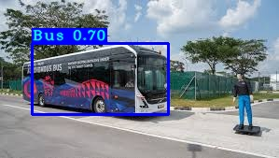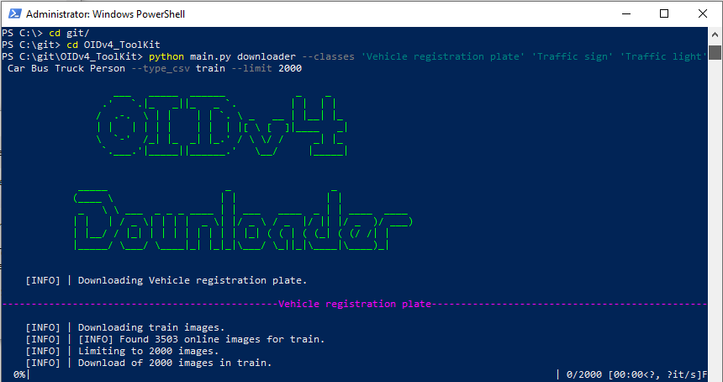

Figure Downloading using OiD_toolkitv4

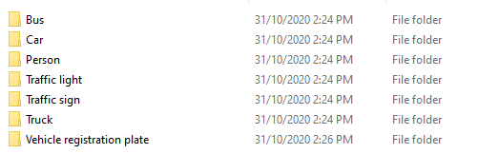

Figure Organised classes from OiDv4 downloader

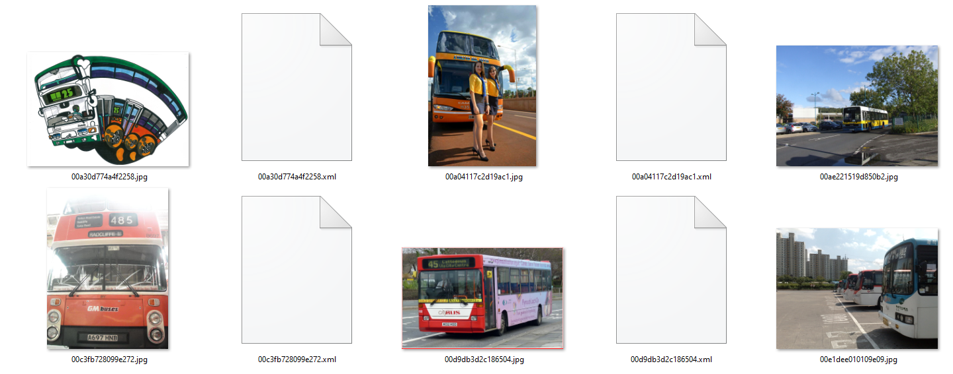

Figure Organised images with corresponding annotations

## **Using the street-sign Dataset:**

From the permission granted from Mapillary to use their dataset of 60,000 street view images all already annotated, I took the initiative implement the images into the neural network as described above. This meant understanding the annotation file supplied by Mapillary which was initially in a .json file with various properties of the image including the class, the bounding box and dimensions of the image as well as some keys. However all most of the properties were not required for the implementation of the neural network.

I soon discover the json format was incompatible with the neural network that I’m trying to implement it with. This meant that I must write a script that will take the properties I needed from within the json file and place it in another text file that was in Yolov3 compatible format for all the images within the dataset. 

Some of the things to look out for in this process was ensuring the directory files had no spaces as this would interfere with the code within the network to locate the folder.

Once this was completed, there were two major problems that occurred. The 1st problem was that the images were about (4000, 4000) pixels on average. Which was much higher than the (416x416) input size yolov3 was made for. This meant that before the network processed the image, it would scale it down to (416x416) before detecting the image. Some speed-limits were already very small within the images and only spanned across 20 to 30 pixels across the 4000 in the original image. Resizing this image by 10x meant that these signs would only be about 2-3 pixels wide. This resulted in a resolution that is far too low for processing. Resulting in a very low mAP of 12.4%.

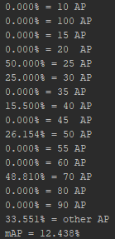

To tackle the this problem, there were two options. The first choice was to remove the images with speed-limits from our dataset. The second was to do a (416x416) crop around the speed limits to remove unnecessary portions of the background.

I’ve modified to python script to filter out images that were too small, however there were only around 1,000 images that were larger that (30, 30) pixels across a total of 4,000. 

The 2nd problem was that most the images within the dataset of 60,000 were not speed-limit signs. I needed to optimise my neural network to primarily detect speed- limits which meant filtering out the images that do not have speed limits.

Again, another python script was required to identify the classes within the annotation files. Find out which files had labels of speed-limits and only select those files to convert to yolov3 annotations. At this completion only 5886 images and annotations remained. 

The sample size was not as large as I initially hoped it’d be so every image mattered and to ensure that all the images were visible, I took the approach of writing code to crop the images around the speed-limit.

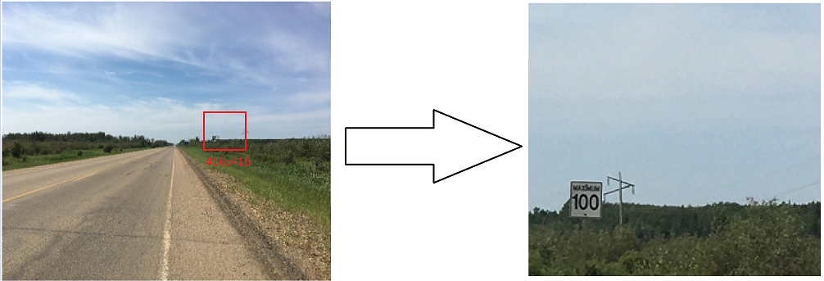

There needed to be an unbiased modification to every individual image in the dataset, so my goal was to randomly crop around the speed-limit. First I used the annotation files to locate the position of the bounding box. Then I randomly generated a number between 0->416 and made a (416x416) crop at that distance from the bounding box. When taking this approach, it’s also necessary to check that the new crop fully encapsulates this image. Two things that could break this condition, were if the bounding box is larger than the new image size (If this is the case, I resized the bounding box and made it a 416x416 image, resulting image is purely the sign). Or if part of the bounding box was cropped out. In this case, I rerolled random numbers until the code found a suitable set of dimensions.

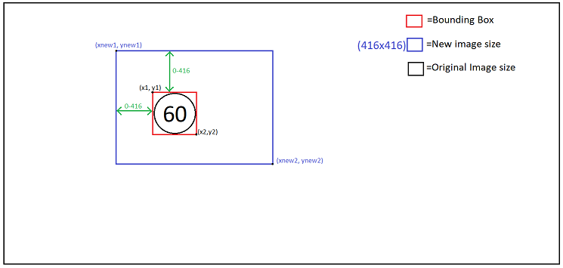

Once the images were cropped the bounding boxes coordinates would also change, so it was important for me to modify the annotation files to follow suit as well, ensuring that the new coordinates were where they were meant to be.

Now that the images are modified, it was time for testing, my first test involved splitting the dataset into training: 5786 and test images: 100. This time the mAP was very high at 84%. While it seems like a much better result, it was not a very robust test 100 images is too small a sample size to encapsulate a good range of scenarios. With only 100 images, there was a possibility that not all the classes were tested as well, since I had 20 different classes for the speed limits.

My next test involved trying 20% of the dataset as test images (1177 samples), 80% as training (4709 samples). The mAP in this case is 64%.

I tried 10% of the dataset as test images (589 samples), 90% as training (5297 samples). The mAP in this case is 66%.

Now that the sample size for the test set is much more robust, my neural network noticeably struggles with certain classes. Upon closer analysis, the individual classes had varying levels of successful detections. This has led to some suspicions about the way the dataset was tested, the results providing 100% did not seem accurate to me.

|  |  |  |  |  |  |  |  |
| --- | --- | --- | --- | --- | --- | --- | --- |
| Speed  limits | 5 | 10 | 15 | 20 | 25 | 30 | 35 |
| AP | 94.12% | 24.28% | 100.00% | 66.24% | 79.72% | 74.81% | 77.17% |

|  |  |  |  |  |  |  |  |
| --- | --- | --- | --- | --- | --- | --- | --- |
| Speed  limits | 40 | 45 | 50 | 55 | 60 | 65 | 70 |
| AP | 81.59% | 76.47% | 70.83% | 64.00% | 58.29% | N/A | 79.25% |

|  |  |  |  |  |  |  |  |
| --- | --- | --- | --- | --- | --- | --- | --- |
| Speed  limits | 75 | 80 | 90 | 100 | 110 | 120 | Not  Speed limits |
| AP | 100.00% | 48.82% | 32.00% | 51.94% | 52.00% | 27.78% | 62.85% |

I tried this neural network on some sample speed- limits on google, and the performance roughly reflected the mAP. Though my model noticeably failed with signs that were black.

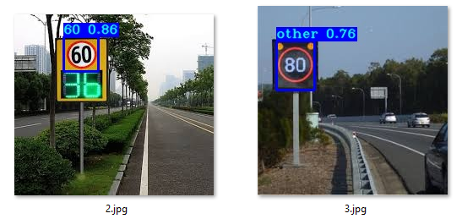

To tackle this, I tried inverting the colours of some of some of the samples in order to mimic the appearance of a black sign. While an interesting idea, I did have multiple concerns. The mimicry was not at a sufficient level as well as limited dataset would reduce the number of normal images I had. When testing the network with 10% of the data as inverted images, as expected the performance did not improve. Though interestingly enough, it did not regress.

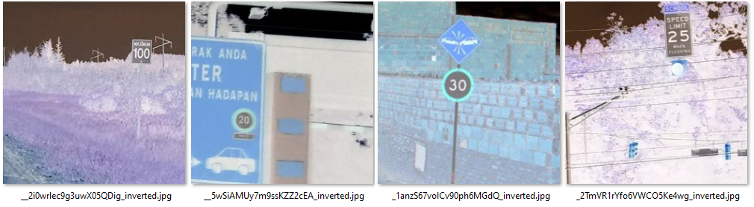

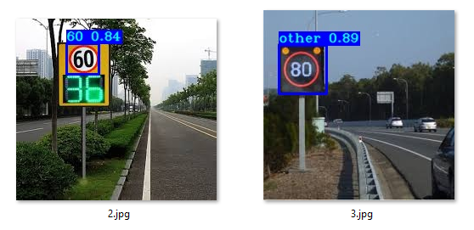

I further tried, instead of modifying the images, I would add inverted images made from the dataset. To avoid as much duplication as possible, the inverted images were cropped randomly independent of the image it stemmed from. I would have also liked to do random flips of the image, however as the speed-limits have numbers and direction is important, that meant the images could not be reversed.

Unfortunately, even with the additional inverted images, there was not enough improvement in performance for the neural network to detect the black speed-limits. Here we also notice that the non-maximum suppression also seems to be unable to distinguish the sign as a singular object.

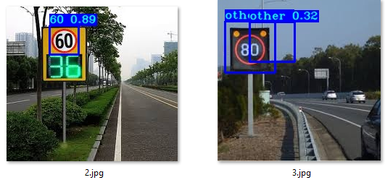

With the goal of further analysing the performance of the network, I set out to measure its performance while it was training. To better understand how the network is improving over every epoch. Some of the factors to potentially look at were the various losses and understanding the behaviour. Looking at the accuracy, **F1 score**, precision and recall and how those would change as the neural networked learned as well as a **confusion matrix**. Various other measurements can be used however these seem to be the best measurements for a classifier like yolov3.

I set the goal to calculate the mAP every epoch and create a graph that would show how this mAP would change over every iteration. Unfortunately, I ran into unknown errors that was beyond my ability to sole trying to implement the mAP in every training loop.

I decided to take it back a step and review the number of samples I had for each class, as I felt that a huge factor in the performance was situated in my distribution of samples. To analyse this, I wrote further code that logged the classes while the data was being prepared.

I discovered that my data is very unevenly distributed with unequal number of classes in a training set, and sometimes having a very low number of samples for some classes in the test set. I also noticed that I had no samples for a speed-limit of “65” in neither the test nor training set. Which meant I needed to remove this from list of possible classes.

I wrote code to evenly distribute the number of samples for each class between the training and test set and surely enough there was a great level of improvement in the mAP now at 73.090%, however still not yet at a desirable level.

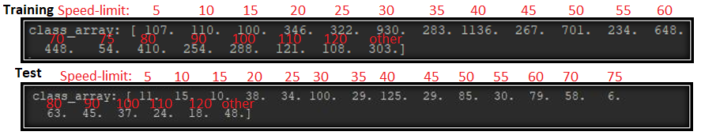

|  |  |  |  |  |  |  |  |
| --- | --- | --- | --- | --- | --- | --- | --- |
| **Speed**  **limits** | 5 | 10 | 15 | 20 | 25 | 30 | 35 |
| **Samples** | 107 | 110 | 100 | 346 | 322 | 930 | 283 |
| **AP** | 100.00% | 65.45% | 90.00% | 86.84% | 94.12% | 86.05% | 98.61% |

|  |  |  |  |  |  |  |  |
| --- | --- | --- | --- | --- | --- | --- | --- |
| **Speed**  **limits** | 40 | 45 | 50 | 55 | 60 | 65 | 70 |
| **samples** | 1136 | 267 | 701 | 234 | 648 | 0 | 448 |
| **AP** | 89.21% | 89.14% | 70.38% | 69.69% | 70.45% | deleted | 73.78% |

|  |  |  |  |  |  |  |  |
| --- | --- | --- | --- | --- | --- | --- | --- |
| **Speed**  **limits** | 75 | 80 | 90 | 100 | 110 | 120 | Not  Speed limits |
| **Samples** | 54 | 410 | 254 | 288 | 121 | 108 | 303 |
| **AP** | 100.00% | 53.29% | 43.88% | 64.45% | 21.88% | 36.86% | 57.21% |

## **Images of results:**

Doing several tests on various images, I’ve obtained images of the results shown side by side with the original image. Overall, the performance does seem to be better the higher the AP, however this does not necessarily mean that the higher the AP the better. The measurement of the AP does not seem to be robust enough to be a pinnacle source of reliability as the sample size for some of the classes test set is too small, to the point where 100% AP is an obvious deception and we see that the performance of a particular class does not match up to its value in the AP on alternate images. Even though speed limits of 5 have 100% ap, they will still be confused with 50’s.

There are still other metrics to consider such as using a confusion matrix to see how much the classes get mixed up, most noticeably between 10’s & 100’s as well as 5’s & 50’s as these will look similar to the network.

The classes the network was the most successful at detecting were noticeably speed limits of 40, 60 ,70 and 80 which is also intuitive as there were the most samples for these particular classes. However interestingly enough 70’s did incur confusion with arrows signs pointing either direction, as the vague structure appears like a 7. The network also struggled to detect street signs that were not speed limits, in hindsight there should have been more samples from the non-speed-limit category instead of filtering out as many as I could.

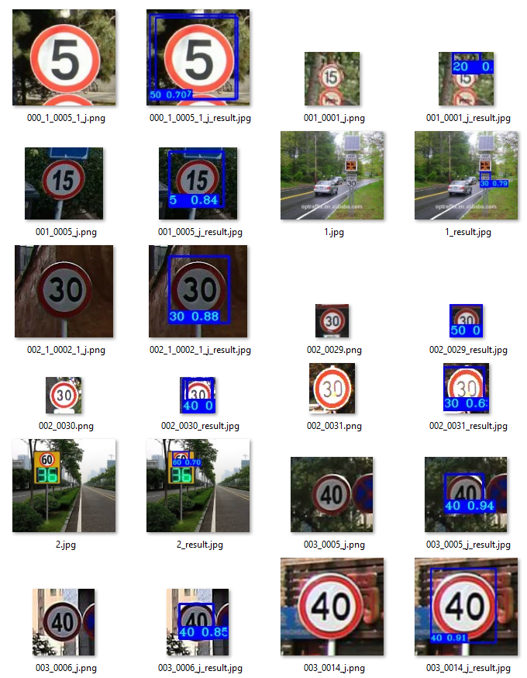

Figure Results page 1

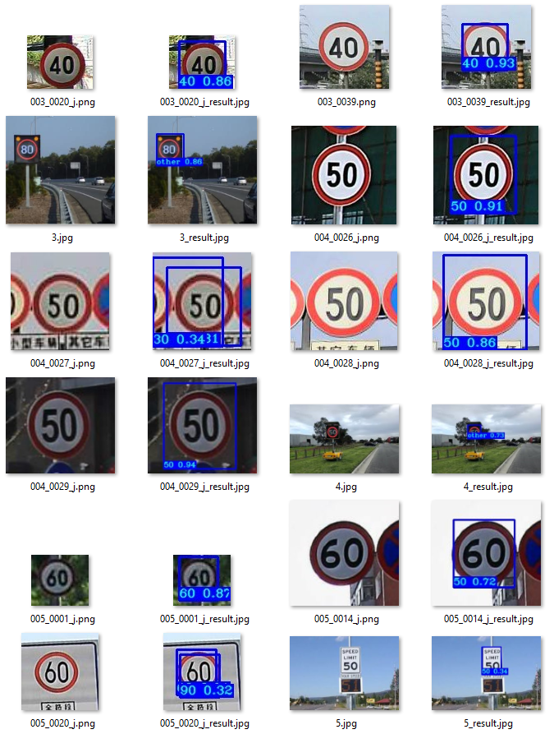

Figure Results page 2

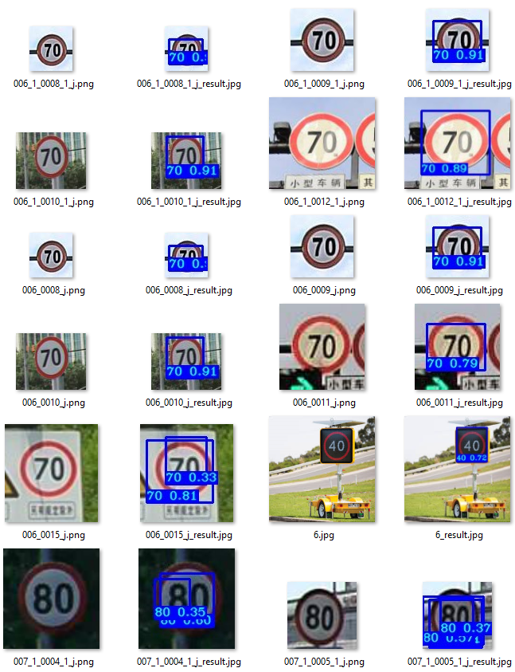

Figure Results page 3

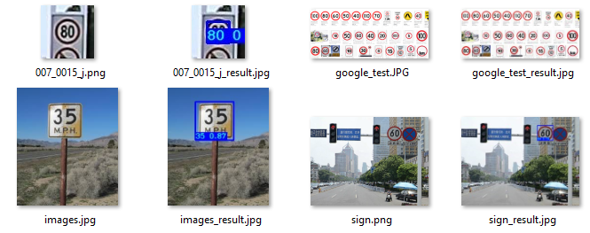

Figure Results page 4

## **Some larger images:**

**Original Results**

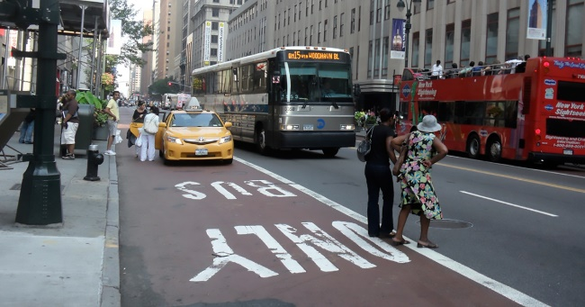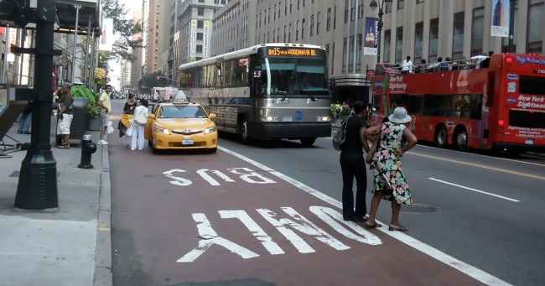

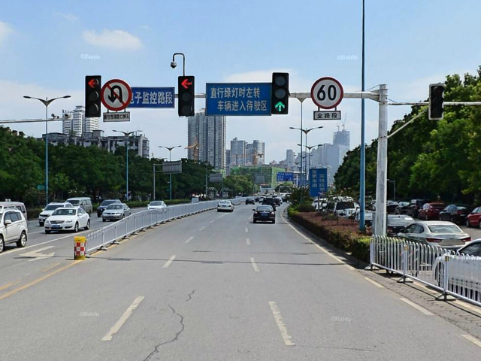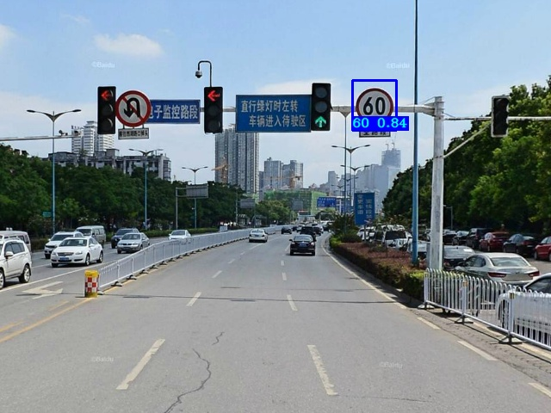

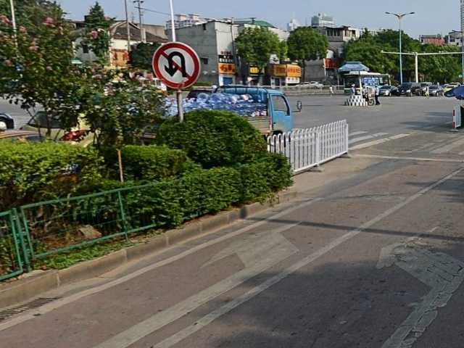

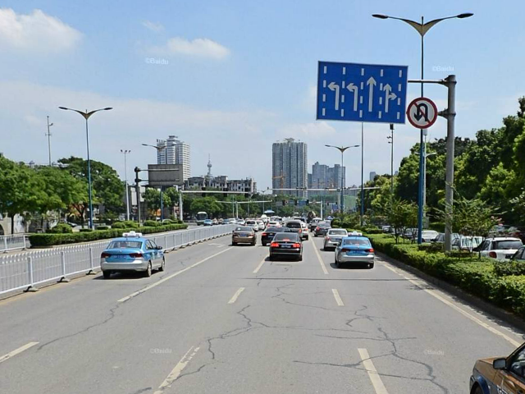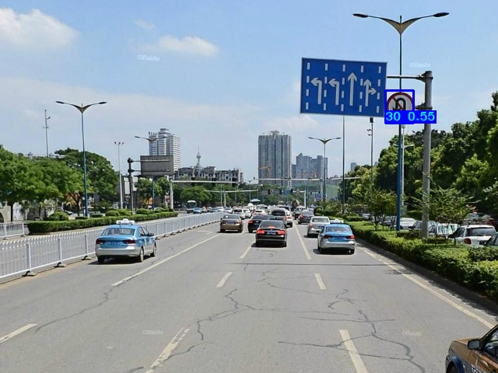

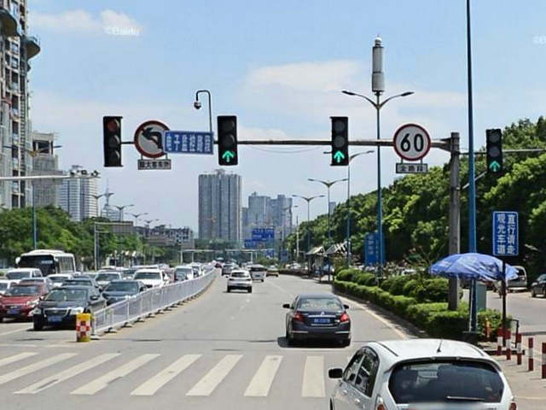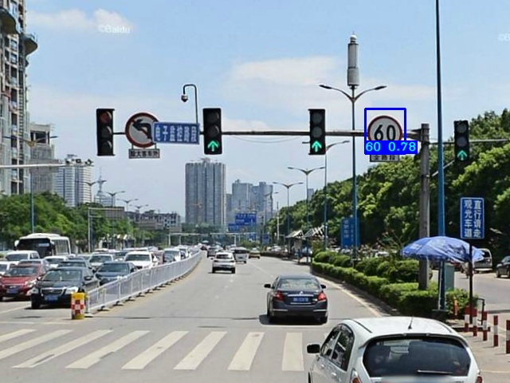

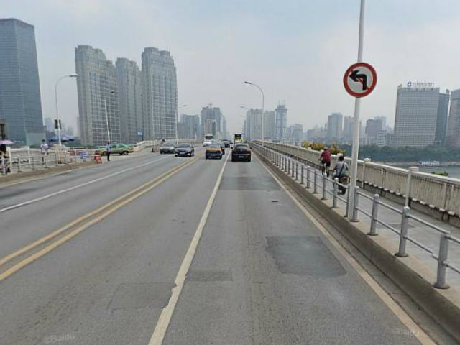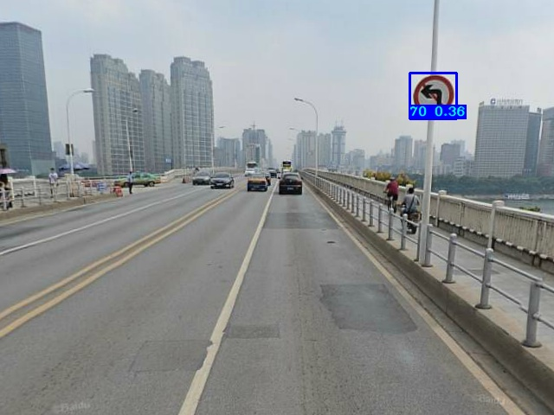

**Conclusions & Future Work**

## **Conclusions:**

Some valuable take aways’ from participating in this project is the ability to code in python which I find most valuable and understanding the TensorFlow framework a little better. There are is also a lot of learning regarding the architecture for this particular neural network as well as understand neural networks and the intricacies of their behaviour better in general

Now that I’m diving into the field a little more, I also learnt that there is a lot more to learn and how expansive this field is becoming and the kind of potential that lies in its development as we progress into the future. I also better under the current limitations as well as the applications for what’s currently possible and what will be one day.

In my progress report I had the original plan to construct the network with the expectation and intent of achieving near 100% perfection in the detection performance of my network and applying it to google maps to map out the locations of speed-signs. However, now looking back at it, there are plenty of hurdles that I did not anticipate at the beginning of my journey that were required before accomplishing such a task. Which lead to my decision to lowering the bar and look for ways to improve the performance of the model I’ve currently built, with the progressively increasing understanding I have of neural networks.

## **Future work:**

Here are Herseveral of the ideas I had added to the list for the future development of this project:

* Apply the neural network twice on 1 image, first detecting the location of the object and classifying it like usual. But also crop out the bounding box area and perform the neural network again on the zoomed in image.
* Develop the neural network so that we can apply purely an object detection for the street-signs, take the detected street-sign and classify the numbers/ shape with another neural network. The aim of this is to allow it to detect numbers better.
* Use the above configuration to not just classify the speed-limits in just a limited number of classes. But identify the numbers, so that it can identify unusual signs.
* Collect a wider range of samples for the dataset to obtain a more plumptious and robust outcome.
* Understand and improve performance speed so that real time object detection can be applied for the usage on the road.
* Apply more non-speed-limit data to prevent confusion from speed-limits

Some other key areas of this project that’d like to have improved on and experiment with is trying out various other types of CNN to measure the performance against the one built in this project.

If I were to do it all again, I definitely would have chosen to build a standard street-sign classifier, that would then crop out the street-sign then perform image classification on that. This would resolve the problem I have with the resolution of my neural network input being unable to use high resolution images or small signs in a large background. As well as specialise the classification to detect the digits that have very clear distinguishable digits well as enabling the classification network to optimise on just classification without impeding it’s results with object detection.

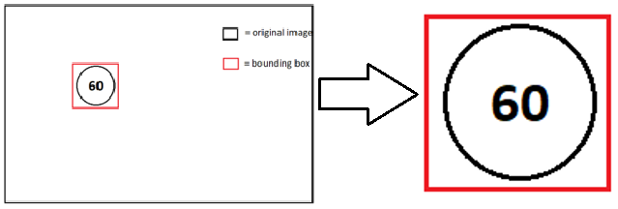

Figure Object detection to classification

Link to google drive:

<https://drive.google.com/drive/folders/1ug8cmV1g4V5-SSBOzvVWGmfOiQT_GKkv?usp=sharing>

Link to video:

<https://www.youtube.com/watch?v=9JuQXXEBuMk&ab_channel=HaoyiSar>

# **References**

|  |  |
| --- | --- |
| [1] | V. Sichkar, “Valentyn Sichkar,” 20 7 2020. [Online]. Available: https://www.youtube.com/watch?v=vRqSO6RsptU&ab_channel=ValentynSichkar. [Accessed 4 11 2020]. |
| [2] | A. Kathuria, “What’s new in YOLO v3?,” 24 4 2018. [Online]. Available: https://towardsdatascience.com/yolo-v3-object-detection-53fb7d3bfe6b. [Accessed 4 11 2020]. |
| [3] | A. KATHURIA, “How to implement a YOLO (v3) object detector from scratch in PyTorch: Part 1,” 16 4 2018. [Online]. Available: https://blog.paperspace.com/how-to-implement-a-yolo-object-detector-in-pytorch/. [Accessed 4 11 2020]. |
| [4] | T. D. V. G. Vittorio Ferrari, “Open Images Dataset V6,” Google, [Online]. Available: https://storage.googleapis.com/openimages/web/index.html. [Accessed 25 10 2020]. |
| [5] | O. Yicong, “Python Google Image Web Scraping,” 18 7 2020. [Online]. Available: https://www.youtube.com/watch?v=QZn_ZxpsIw4&ab_channel=OhYicong. [Accessed 15 9 2020]. |
| [6] | J. E. Solem, “Mapillary,” 1 1 2014. [Online]. Available: https://www.mapillary.com/. [Accessed 3 3 2020]. |
| [7] | Sentdex, “Sentdex,” 17 12 2012. [Online]. Available: https://www.youtube.com/user/sentdex. [Accessed 2020 10 30]. |
| [8] | Socratica, “Socratica,” 25 12 2011. [Online]. Available: https://www.youtube.com/c/Socratica/. [Accessed 25 10 2020]. |
| [9] | freeCodeCamp, “freeCodeCamp.org,” 17 12 2014. [Online]. Available: https://www.youtube.com/c/Freecodecamp/. [Accessed 5 10 29]. |
| [10] | “YOLO object detection using Opencv with Python,” 27 6 2019. [Online]. Available: https://www.youtube.com/watch?v=h56M5iUVgGs&t=569s&ab_channel=Pysource. [Accessed 23 5 2020]. |
| [11] | V. Mazzia, “OIDv4 ToolKit,” 25 6 2019. [Online]. Available: https://github.com/EscVM/OIDv4_ToolKit. [Accessed 31 10 2020]. |
| [12] | J. Redmon, “YOLO,” 2018. [Online]. Available: https://pjreddie.com/darknet/yolo/. [Accessed 10 25 2020]. |
| [13] | P. Lessons, “Python Lessons,” 18 9 2018. [Online]. Available: https://www.youtube.com/channel/UCZ8qczwOOrL8ywaCRz5WUjw/. [Accessed 31 10 2020]. |

**Appendices**

## **Definitions for convenience:**

**Anchor boxes:** Bounding boxes with a predefined width and height. Therefore, the values for the anchors are not predicted. They are usually used to capture the size and aspect ratio of an object.

**Ground truth:** The annotated data on the image that gives the class and coordinates on an object within an image.

**IoU:** (Intersection over union) Used to measure how much of a predicted bounding box overlaps the ground truth bounding box. With 1 being the desired value.

**Stride:** The number of pixels you jump across in an image. Which is used to down sample images.

**Down sampling:** Down sampling compresses and removes details from the image, as the image is processed through each layer of the neural network.

**Objectness score:** A prediction made by the neural network of the likelihood that a particular area contains an object.

**Feature map:** The output of a single layer within a convolutional neural network.

**Kernals:** Convoluted with features maps to obtain desired features in the form of another feature map.

**non-maximum suppression technique:** A technique used to select the best predicted bounding box and supress all other bounding boxes.

**sigmoid/ leaky relu:** Known as activation functions that are used to remove linearity within a model.

**Weights:** These add or reduce the significance of particular nodes in a neural network.

**forward pass:** The regular start to finish process of a neural network.

**Epochs:** The number of times a neural network is trained over the same set of images.

**Batch sizes:** The number of images the neural network trains in one iteration.

**Accuracy:** Ratio of correct observations over total observations. $\frac{TP+TN}{TP+FP+FN+TN}$

**Precision:** Precision is the ratio of true positives to the total predicted positive observations. $\frac{TP}{TP+FP}$

**Recall:** Recall is the ratio of correctly predicted positive observations to the all observations in actual class. $\frac{TP}{TP+FN}$

**mAP:** (mean Average precision) AP provides a combination of recall and precision for single class classification. mAP is across all the classes.

**F1 Score:** The F1 score is $\frac{2*precision*recall}{Precision+recall}$ , it conveys the balance between the precision and the recall.

**Confusion Matrix:** A matrix that shows the mix-up between the classes, by showing how often the classes are predicted correctly, and what the incorrect predictions are.

